SPC-DT Program User Manual

Version 0.1

July 1st 2022

This manual serves to guide the user through loading the parser, data, and interacting with the visualization.

To open the program, double click the “OpenGL_on_a_Windows_Form.exe” file.

# Step 1: Loading the Parser

1. Begin by pressing the “Upload Parser” button, which opens a file selection window.

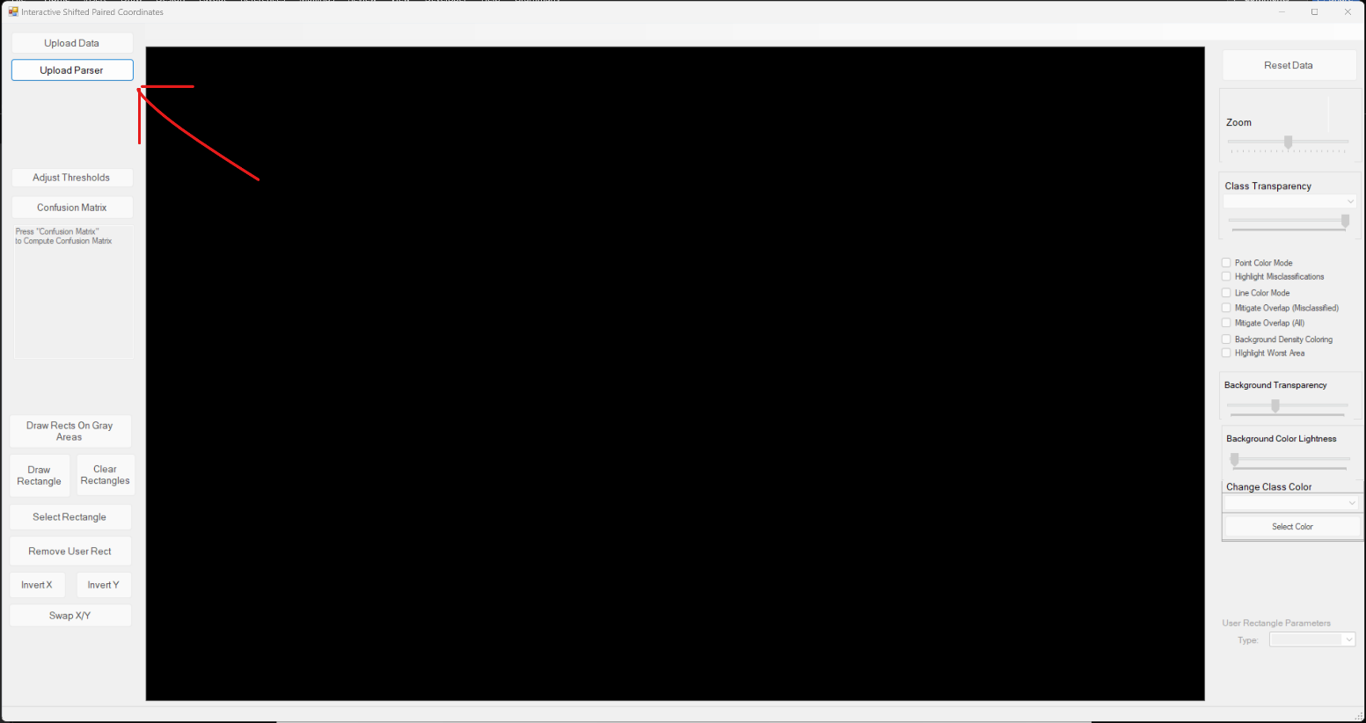

1. Select the file “irisParserUpdated.txt” in order to load the decision tree data into the program. **You will not see any visuals yet.**

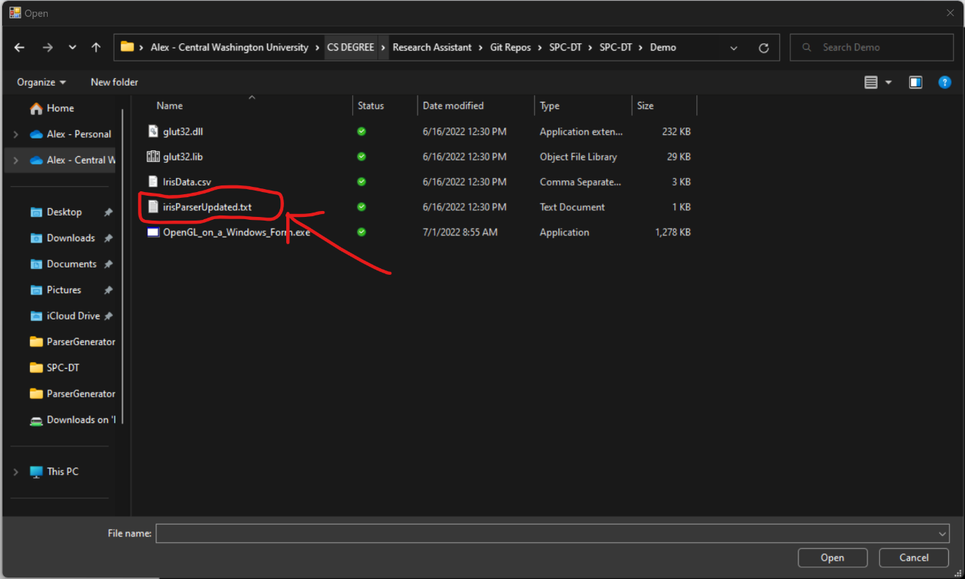

# Step 2: Load Data

1. Press the “Upload Data” button at the top left of the screen. This will open a file selection window.

1. Select the “irisData.csv” file. This will upload the data into the program. **After this you will see the visualization.**

# Rearranging the Plots

The user may now drag the individual plots into locations that are best determined by the user.

# Altering Visualization Parameters

The user may control various aspects of the point visualizations:

## Point Color

The termination point color can be set to that of the case’s class color using the “Point Color Mode” checkbox on the right of the screen.

## Misclassified Points

The “Highlight Misclassifications” checkbox may be enabled to surround points that have been misclassified by the decision tree with a red border.

## Line Color

Lines can be colored depending on their case’s class using the “Line Color Mode” checkbox.

## Overlap Mitigation

In some datasets, points may overlap eachother resulting in only the top point being visible. This can be mitigated using the “Overlap Mitigation” checkboxes. There are two versions: one that only mitigates points in which more than one class is represented and another where all overlapping points are mitigated.

## Background Zone Color Density

The mode enabled by the “Background Density Coloring” checkbox alters the colors of the zones behind points according to the overall accuracy of the zone. A darker color indicates a stronger decision tree rule, while a lighter color indicates a weaker decision tree rule. White borders are drawn around some points to aid in their visibility.

## Background Color

### Background Transparency

The background transparency slider controls the alpha value of the background zone, resulting in colors that vary in transparency.

### Background Color Lightness

The background color lightness slider controls the brightness of the background zone color, defined by the lightness value in the Hue, Saturation, and Lightness color representation.

## Class Color

The color of a particular class in the dataset can be changed using the “Change Class Color” combo box.

Next, press the “Select Color” button right below the combo box in order to pull up the color panel.

Once a color is selected, press the “OK” button and the color will be applied to the selected class.

## Threshold Adjustment

Using the “Adjust Thresholds” button on the left, edges will be drawn on the areas between decision zones. The user can drag these thresholds in whatever way they like, changing the structure of the decision tree. The user will be able to see the effects of the changes they make in the confusion matrix on the right middle of the screen.

## Condensing Gray Areas

The user can condense all the points that fall into a gray area to improve readability of the visualization. This is particularly useful when many lines are overlapping within a gray area.

## Draw Rectangle

The user can draw rectangles on the visualization in order to localize a particular visualization technique to the area within the rectangle. At present, the only supported option is to condense the points within the rectangle.

To draw a rectangle, select the button, then click two points that represent the opposite corners of the rectangle.